Name__________________________ period____
Unit One: Colonial America Prezi Notes (this goes in your INB—use for STAAR prep)
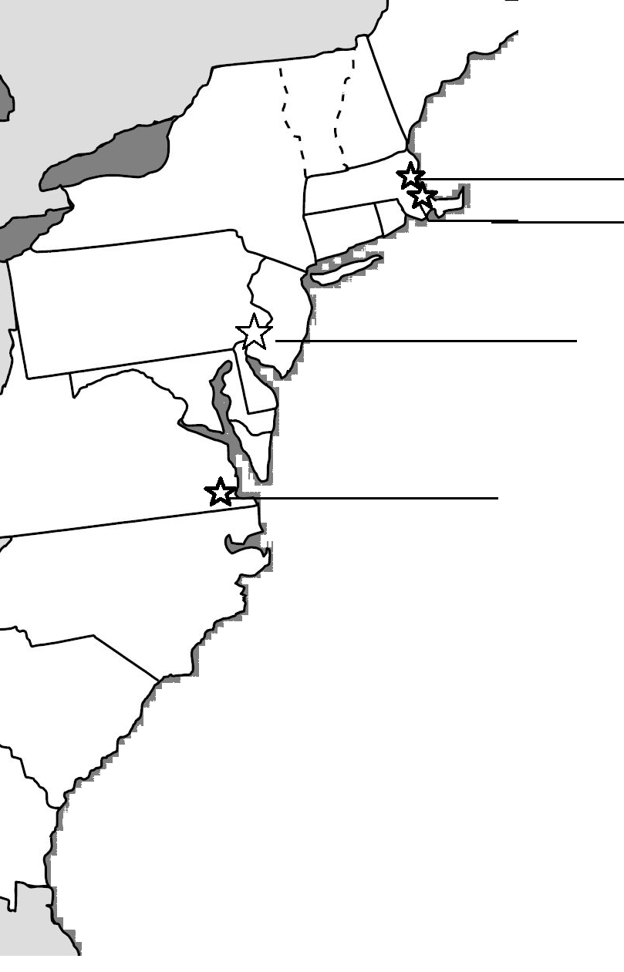  Label the following on the map above with its proper symbol:  Jamestown=JT  Plymouth=PL  Boston=B  Philadelphia=PH  Draw a symbol or picture below to illustrate your answer to the questions in the boxes:  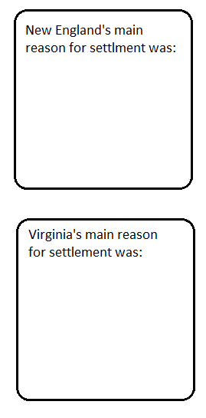 | Introduction:  English settlers attempted to establish a colony called__________________________, that disappeared.  Jamestown: the first permanent English colony (established in ____________)  - The London Company was a________-__________ company, similar to an investment group  - The expedition was led by ____________ _______________, who was unpopular but efficient  - Tobacco was a crucial _________ __________ that allowed the colony to thrive  - They faced several challenges such as _____________, _______________, _______________  - Work was done mainly by ______________ _________________, who could not afford passage on their own, and were promised __________ at the end of their term.  New England Colonies: Religious Freedom  - Pilgrims were Puritan _______________that wanted to split from the Church of England and form their own utopia.  - In 1620, they arrived in the New World and signed the ____________ _______________—the first document establishing a self-government in America.  - The colony established itself in ________________.  - They had trouble their first winter because ___________________________________________  - By the first Thanksgiving, only ______ of the original 102 pilgrims survived (only 4 of which were women).  - The colony was led by ____________ __________________  Massachusetts Bay Colony  - In 1630, a much more organized and prepared voyage brought more Puritans to America, led by ___________ _______________  - This group sought to __________ the Church.  - They eventually created the city of _________________.  - The success of their colony led to a Great Migration of nearly 10,000 Puritans from England.  - This population boom led to conflict with _____________.  - Examples of people who were banished from the colony included ___________ ____________, _______ ______________, and ____________ _________________ who was hanged  - In 1636 they founded ___________________.

Unit One: Colonial America Prezi Notes page 2
Higher order questions:  How might a Quaker deal with Native Americans vs a Puritan or Southern Planter? Explain your answer.  Before Rhode Island was established, its founder was banished from Massachusetts. How might this influence the laws of his new colony?  How would the indentured servants feel toward the aristocratic planters they once served? | Other Colonies:  Pennsylvania  _________________ advocated pacifism, a more internalized religious practice, and individual freedom.  ____________ _________, established Pennsylvania.  Its capital, ________________, was a Greek term meaning brotherly love.  Rhode Island was founded by __________ ____________ and became a safe-haven from religious persecution.  Maryland was founded by ________ ____________ as a haven for Catholics  Connecticut was founded by _______________ _______________.  Its Fundamental Orders of Connecticut was the first written Constitution in America.  In the Southern part of America, North Carolina and South Carolina were founded as separate expansions of _________________, which had spread too thin to remain one colony.  _________________ was founded as a colony for the growing numbers of indentured servants who had earned land and survived to claim it. It was strategically placed between English settlements and Spanish territory as a buffer zone.  Other Major Events from the Colonial Era that influenced life in the Americas:  Of the events below, circle or highlight the 5 that you think are the most important in shaping America…  1497- John Cabot is first European to explore mainland.  1588- Defeat of the Spanish Armada-  1622- Indian massacre against Virginian settlers  1624- New Netherland founded  1637 – The Pequot War  1642 – Beginning of the English Civil War  1664- England captures New Netherland and renames it New York  1675- King Philip’s war  1676- Bacon’s Rebellion  1692 – First of the Salem witch trials.  1718 – Blackbeard killed.  1741- Jonathan Edwards preaches "Sinners in the Hands of an Angry God"  1754 – Outbreak of French and Indian War  Which event is the most important to you and why?

