Name_______________________________ period______
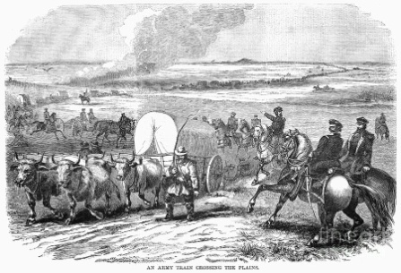
Unit 6: Westward expansion Prezi notes
Northwest Ordinance Review:
Northern states gave up western territory to help pay off debt.
Did not allow _____________________________
Describe the Rights a citizen had in territories vs states:
Had to have __________ people to elect their own governor (he was appointed prior to this).
Had to have _______________people to apply for statehood.
Manifest Destiny
Looking at the painting “American progress” by John Gast:
- What attitudes are expressed about Manifest Destiny?

- Who represents American progress in the painting?

- How do technology and transportation play a part in westward expansion?

- What is the reaction of the Native Americans in the painting?

- What is American exceptionalism? How does it relate to the idea of Manifest Destiny?
- When people moved west, what are 3 examples of what they were looking for:
- Was all immigration into Texas from America legal in the 1820s-1830s?
- What consequence did this influx of Anglos lead to?
People Moving West:
Many of the people moving west could not ______________ land in the east.
Land in the east was becoming less fertile due to ___________ - _____________.
Other motivations included a desire for ______________ and _____________-- characteristics still celebrated in America today.
Groups included Irish, Germans, Scandinavians, Scots, and Mormons.
They usually lived a harsh, rustic life with few luxuries.
Cabins were small and cramped.
Hardships were countless and included malnutrition, isolation, _____________, scarcity of supplies, Indian attacks, and feuds with other neighbors.

What famous western trails do we need to know for this class?
___________________________- a trading route was established with silver mines in New Mexico.
____________________________- settlers moved to the Pacific Northwest, facing many hardships along this journey.
____________________________- religious Zionists moved to the Great Salt Lake to escape persecution and build their society.

War with Mexico
In 1845, ________________________ (a believer in manifest destiny) became president of the US.
After Texas was annexed, Mexico was outraged. The US sent American troops to Texas and picked a fight.
The ______ _________________ War lasted from 1846-1848
It was a complete American victory.After American forces occupied Mexico City, Mexico was forced to sign the Treaty of ______________ ______________________.
It resulted in the ______________ _______________-- America gained what now includes much of New Mexico, Arizona, Nevada, Colorado, Utah, Wyoming, and (most importantly) California.

Gold in California
in _____________, Gold was discovered in California
this caused a "gold _________" in which thousands of Americans flocked west to become rich.
Timeline of US Growth
1803__________________________________- doubles the size of the US after this land is purchased from France. It opens the door for westward expansion.
1819___________________________________- negotiates the transfer of Florida from Spain in exchange for a clear boundary with Texas.
1845___________________________________- The Lone Star Republic is annexed as a US state (upsetting Mexico)
1846___________________________________- Pacific Northwest territory draws border between US and British Canada at 49th parallel, allowing US to claim all southern parts.
1848___________________________________- results in the Mexican Cession of all northern Mexican lands (CA, AZ, NM, CO, WY, UT, NV)
1853___________________________________- strip of land along border with Mexico is bought to build a railroad and end border conflicts.
The Unique American Landscape
What do you think is unique about the American Landscape?

____________________________________- a fraternity of landscape painters that revolutionized American art and brought attention to the natural elements of this nation.

____________________________________ - a famous painter and naturalist that catalogued every bird in America while exploring the western frontier.

